Book Rental Center Analysis
- Project Overview
This project analyzed Book Rental Center’s overall operations with a focus on book inventory, rentals, books per branch, and the employees’ salary. The goal for this analysis was to provide insights about inventory status, branch inventory, and salaries compared to the number of branches and their inventory.

2. Dataset Summary
- Columns: 27
- Rows: 88
- Book management ( Title, Author, ISBN, Rental Price, and Status)
- Book issuance (Issue date, Book issued, To whom, and By whom)
- Book returns (Issue date, Book issued, and Return date)
- Patron management ( Patron name, address, and registration date)
- Employee management ( Employee name, salary, position, branch location and employee ID)
- Missing data: None
3. Exploratory Data Analysis using Postgres
Goal: Clean data and check for null values
- Each table was reviewed manually for spelling error, extra white spacing, data type match and inconsistencies in the data
- Each table was reviewed manually for any null values. No null values were found in the data.
- Next, the SQL querying of the data begin.
4. Data Analysis with PostgreSQL
- Total number of patrons
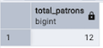

- Total books currently in the system
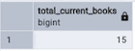

- Total books in the system (past and present)
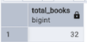

- Total books currently rented to patrons
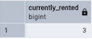

- The number of books rented per patron in descending order
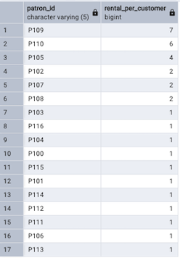
- Number of books issued from each branch
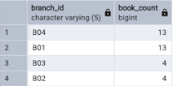

- Names of employees whose salary is greater than 60000
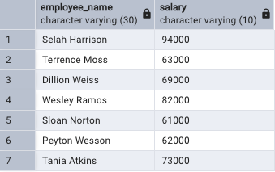

5. Data Visualization using Tableau
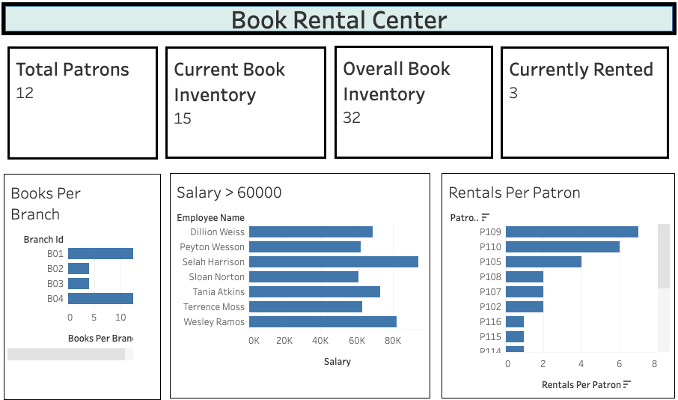

6. Business Recommendations
- Investigate the reason for more than 50% of the book inventory being missing
- Reduce number of branches until sales increase
- Negotiate the salaries of employees greater than $60,000

